Bias Calculator

Info

Bias Calculator
This spreadsheet will help you determine whether your exam is biased according to EEOC guidelines. It provides tabs to evaluate bias by Age, Race and Gender.
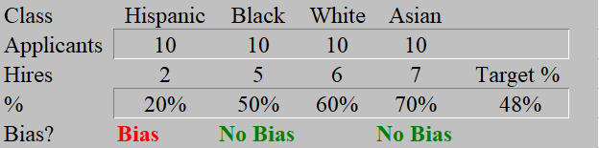
What Is the Bias Calculator For?
If your exam is used for pre-employment testing, or for promotion or performance evaluation, you will want to determine whether the exam exhibits bias toward a protected group.
This worksheet helps you determine whether there is an appearance of bias in your exam. If bias appears, then you may use training, recruitment, or score adjustment to remedy the bias.

How to Use It
Go to the Race tab.
In row 3, enter the number of applicants of each protected group that you want to analyze.
In row 4 enter the number of applicants from each protected group that were hired.
The target employment percent will appear in cell H5, and determination of bias for each protected group will appear in row 5.

