Domain Weighting Tally

Info

Domain Weighting Tally
Tallies domain weight votes from each voter and compiles them into a composite average, showing average domain weight.
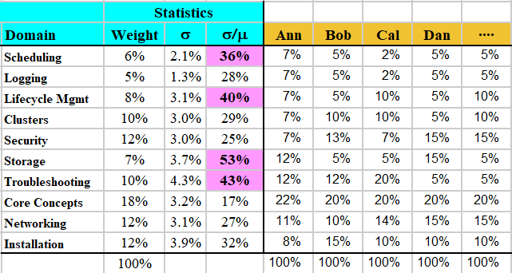
What Is the Tally Sheet For?
In a test-development workshop or JTA workshop, you often want to have the SMEs vote on their weighting of each domain. But integrating their votes into a single worksheet can be time-consuming.
Using this worksheet as a template, you can distribute individual worksheets to every SME. They record their votes on the worksheet, and email them back to you. After you’ve copied each worksheet into the right tab, the votes will all be tallied in a single region, in columns B through F. And domains in which there is substantial disagreement will be highlighted!

How to Use It
Go to the Annie tab.
Change the Domain name rows – add if you need more than 11, delete if you need fewer than 11. Then enter the Domain names for your exam.
Then edit the Domain Weight column. This should come directly from your exam blueprint.

