Scaled Score Converter

Info

Scaled Score Converter
Converts a raw score into a scaled score with arbitrary top score and bottom score. Converts individual scores as well as creates a table of the entire range of scores.
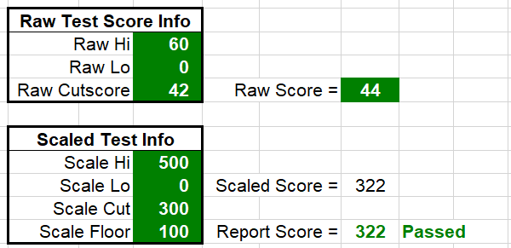

Why Use a Scaled Score?
There are many reasons you may want to report a scaled score rather than a raw score.

For Uniformity within an organization
If your organization delivers more than three or four tests, it may be difficult for support to keep track of the cutscores and maximum scores of each test. So for every call, they have to look up a table of cutscores & score ranges for a particular test.
If all tests are reported on the same scale with the same cutpoint, then they can respond immediately to appeals or complaints.

Maintain comparability between versions
As your test is revised year after year, there may be slight variances in the number of items on the test, or on the cutscore for each version. Using a scaled score allows you to report every version of the test in a common scale, and assures candidates that each of the exams are equivalent.

Minimize support calls
When raw scores are reported to candidates, and a candidate gets a raw score of 1 point below the cutscore, the candidate will often call to appeal just one point. A graphic wasn’t clear. The testing experience was too noisy. A response on one item is scored incorrectly. Candidates can get very creative for one point.
To avoid the one-point appeal, scale the scores so every raw score point is equivalent to 3 scaled points – or even better, to 3.45 scaled points. The candidate doesn’t need to know what the scaling factor is, and when candidates don’t know what it is they’re less likely to appeal.

What Is an Ideal Scale?
First, what an ideal scale is not – it is not a scale from 0 to 100. Candidates will automatically assume a 0 to 100 scale is a percent – which it may or may not be.
A better scale is from two or three hundred to six to nine hundred, with an easily remembered cutscore.
A formula that attempts to simplify the decision is:
By Reference.

How to Use
Edit any cell with a green background and white font.
This will allow you to create a scaled score of virtually any range.
Not only will it allow you to scale single scores, it will build a table of scores on the tab Scale Table that shows scaled scores from the lowest to the highest raw score. You can print this table and use it to check the calculations and for reference if you have lots of lookups in a small amount of time.

